5 Simple Steps to Set-up Accommodated Testing Time Using Canvas
- Click the Quizzes link in the Navigation bar on the left.
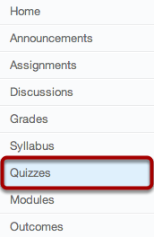
- Click the name of the quiz you want to accommodate. (We’ve called the quiz “Take This Quiz” for this example.)
- Click the Moderate This Quiz link on the right side of the screen.
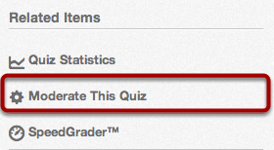
- Click the Pencil icon by the name of the student whose quiz you want to moderate (adjust the test taking times).
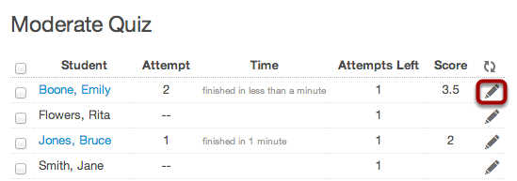
- Type the number of extra minutes in the Extra Time on Every Attempt field [2]. For example, if you set the quiz with a time limit of 60 minutes and a student has “Time and a half” as a disability-related testing accommodation, type in the number 30. Then click the Save button [4].
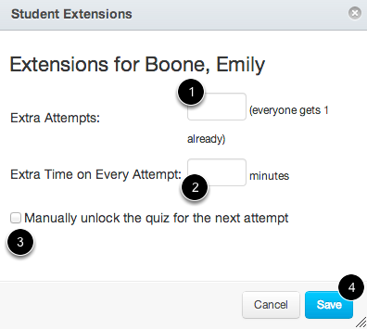
Congratulations! You have now successfully set the student’s accommodated testing time.

For eLearning technical support, please visit:
http://www.clark.edu/academics/eLearning/tech_support/index.php
For any questions related to accommodations for students with disabilities, please contact the Disability Support Services Office at 360-992-2314, or 360-991-0901 video phone, or visit our website at www.clark.edu/DSS.

