**Preferred Email in ctcLink Assignment**

**Purpose:**

This is a quick, 5 point assignment that has you look at how Clark College is communicating with you electronically. In order to complete this assignment, you will read through the following information that explains more about your Preferred Email address in ctcLink, as well as how to change it, if necessary.

**Your “Preferred Email” in ctcLink**

What do we mean by your “preferred email” in ctcLink? This is the email that you have selected as the address where Clark College will be sending electronic communications to you. By default, this is the email address that you used when you initially registered at Clark.

You can see your preferred email indicated on the **Contact Details** page of your **Profile** in ctcLink.

Is this the best email address for the college to communicate with you? If it is, you are all set. If it’s not, please change your preferred email. In order to change your preferred email, you have to add another email address.

**Clark Student Email**

It is a best practice to have a “school” email address that you use which is focused on your academics and centralizes all of your communications from Clark College.

As you will read on the Clark Email link: “*Students who are registered for classes at Clark College are entitled to a Clark Student Email account. The college offers a free email account using Student Gmail. This gives a student access to all the Google Suite applications including Google Drive, Google Docs, Google Forms…*”

You can find information about your Clark Student Email by going to the **Clark Students** page, and then scrolling down to find the link to [**Clark Email**](http://www.clark.edu/its/documentation-and-resources/students/emailsetup.php) under the **eLearning and Communication** resource list.

Consider adding your Clark Student Email address and making it your preferred email in ctcLink.

**How to change your Preferred Email**

If you would like to change your preferred email, you can do so once you have **added another email address** to your profile. Here are the instructions to add another email address into your ctcLink profile:

Go to your **homepage** and the **profile** tile. From here, go to **Contact details** to add email or phone numbers.  Click the **+** sign. Once you have added another email address, you can change that one to be preferred. Here’s what that screen looks like:

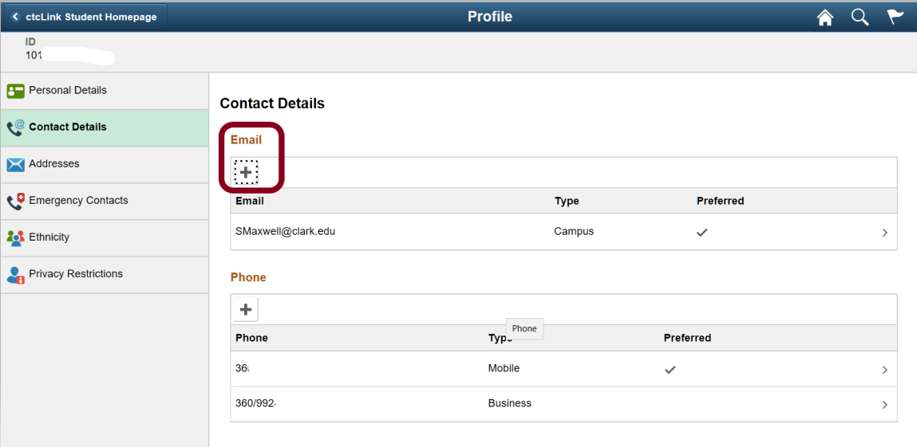

**Task:**

Now that you are now clear on your Preferred Email address, please use that preferred email address to send me a quick email. You can find my Clark Email address on the first page of the syllabus. This email only needs to briefly say that it is coming from your Preferred Email address in ctcLink.

Sending me this email will confirm that you are aware of your Preferred Email address, and that you are aware of how to communicate with me outside of Canvas.

**Criteria for Success:**

Once I receive your email, I will give you the 5 points you have earned in Canvas.