Tips and Tricks

General
- Your Gateway always remains open on a separate tab. Don’t try to arrow back, just go back to the tab.
- Watch this short Video on 9.2 Basic Navigation
- Clear your cache!

Add to Favorites
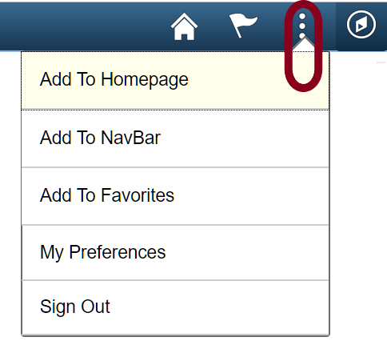
If you find you navigate to a page regularly go ahead save it for easy access. You can save to 3 different places:

When saving a favorite make sure you save it before you have any data on the screen.

Homepage
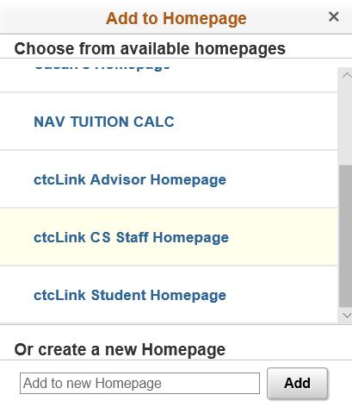
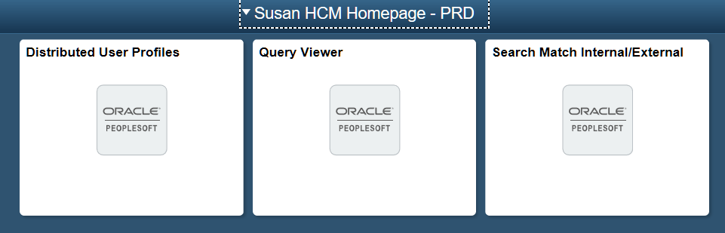
Homepage. These are the tiles you see when you enter a pillar (CS, HCM, FSCM). You can create a new homepage with all your favorites and then make it the default homepage, so that every time you enter a pillar using the top row navigation your favorites are right there. Or you can add to an existing Homepage.

When you add a Homepage you can note what pillar you are in.

NavBar
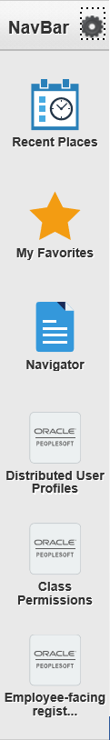
This is your NavBar. Depending on the size of your screen and font size you only have room for two or three additional icons that you can see. If you add more you will need to scroll to see what is available.
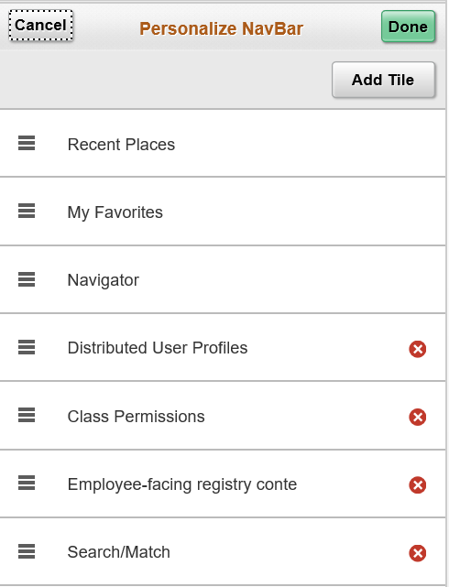
You do have the option to click on the circle next to the NavBar to Personalize your NavBar. You can add tiles, or click on the red x in the circle to remove them. You can also drag and drop to reorder.
TIP:
If you have a sequence of processes to run, add them as favorites and names them starting with the step number.

My Favorites
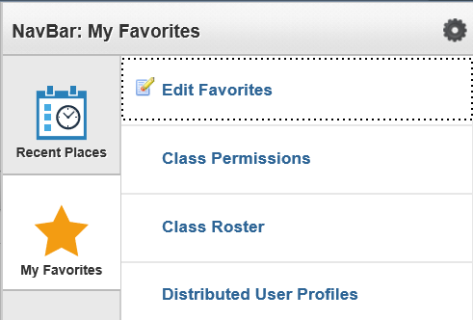
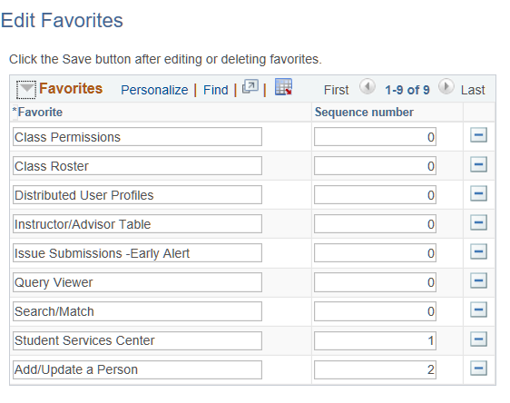
The My Favorites star can be found on your NavBar. At the top you have a link to Edit Favorites, followed by all your favorites.
Unlike the drag and drop functionality of personalizing your NavBar, you need to enter a sequence number to reorder favorites.

SACR User Defaults
Navigation: NavBar Navigation Set Up SACR User Defaults

Tab 1 - Sets defaults for Academic Institution field, Term field, Career field, Academic Program field & others.
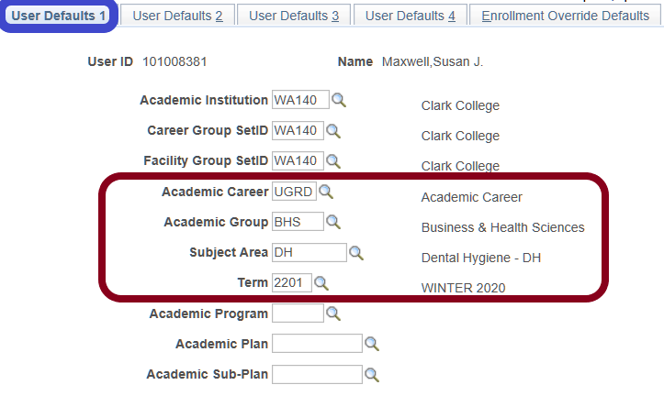
WA140 – Clark College should be filled in for Academic Institution.
Anything in the red box can be set as a default: Academic Career, Academic Group; Subject Area: and Term.
If you work with a particular instructional unit you can default to that unit and not have to see the other units when this is a selection options.
If you do a lot of processing set your term to the current term. Remember to change when you need to move to a new term.

Tab 2 - Sets defaults for the setID field, Aid Year field, Application Center field, Cashier's Office field & others.
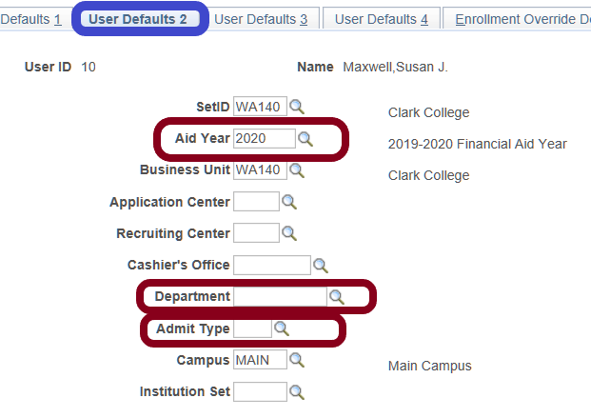
If you work with financial aid data you can default to the Aid Year you want.
Department allows you to default to one business Department – not advised at this point.
If you work with admissions and focus on one type of applicant you can default here.
TIP:
If you are doing a lot of data entry, organize your data by a field that you can default. Enter that group of data. Then come and set the default to the next group. The 30 seconds it takes to change a default can save a lot of time.

Tab 3 – Sets defaults for Admissions Application data
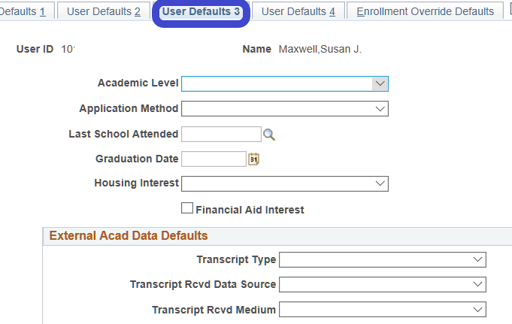

Tab 4 - Set defaults for printing transcripts, including transcript output destination and transcript type, SEVIS processing, and award-notification printing.
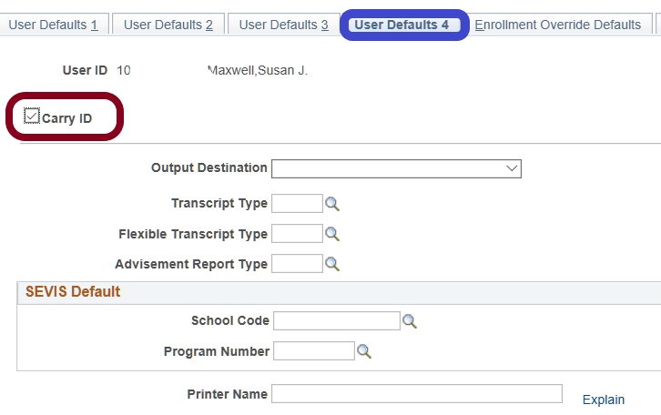
If you want to be able to look at multiple pages for a student and not have to continue to enter the ID on each screen check the Carry ID Box.

Personalize Your Homepage
Click on the 3 dots to edit the homepage you currently have open.
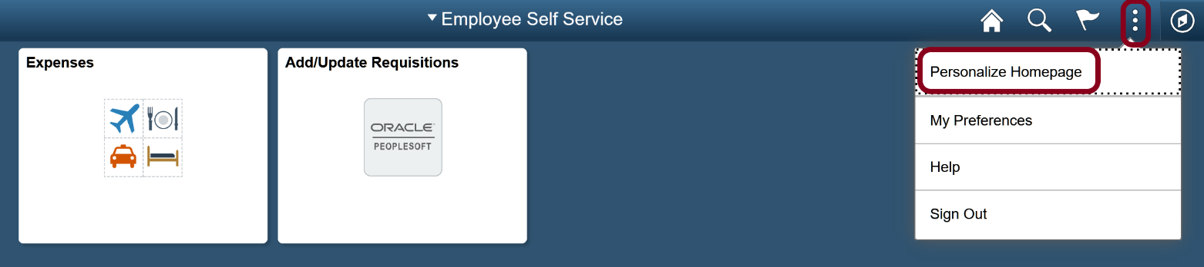
You can drag tiles in a different order, delete tiles, copy or move to a different Homepage.
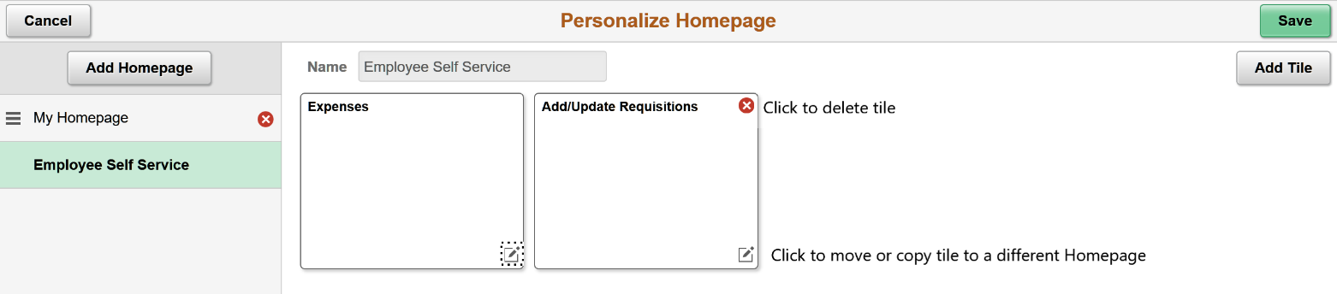
The order on the left sidebar is the order you will see Homepages. The top one is your default. Drag a Homepage’s name to change the order.

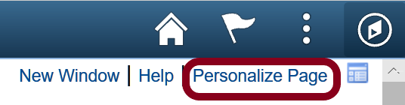
Personalize a Page
When you are on a page that allows for personalization you will see the option in the right hand corner.

To personalize, go to the tab you want to have open first, and select view all if you want to change that. Then click on Personalize Page from the upper right hand corner of your screen. Check the first two options (or whatever options you want to change).
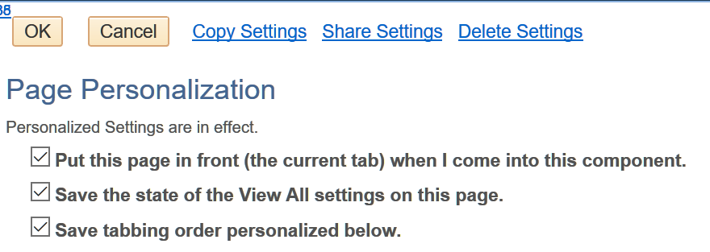
For those who do a lot of data entry you can change the tabbing order on a page, or what field you go to when using the Tab key. You can skip fields you do not use, or change the order you like to enter data.
This image shows the default tabs changed from General to User Roles – because User Roles is the tab that I always use first. I also like to see all rows (which will show up to 100 at a time) instead of 10 rows.

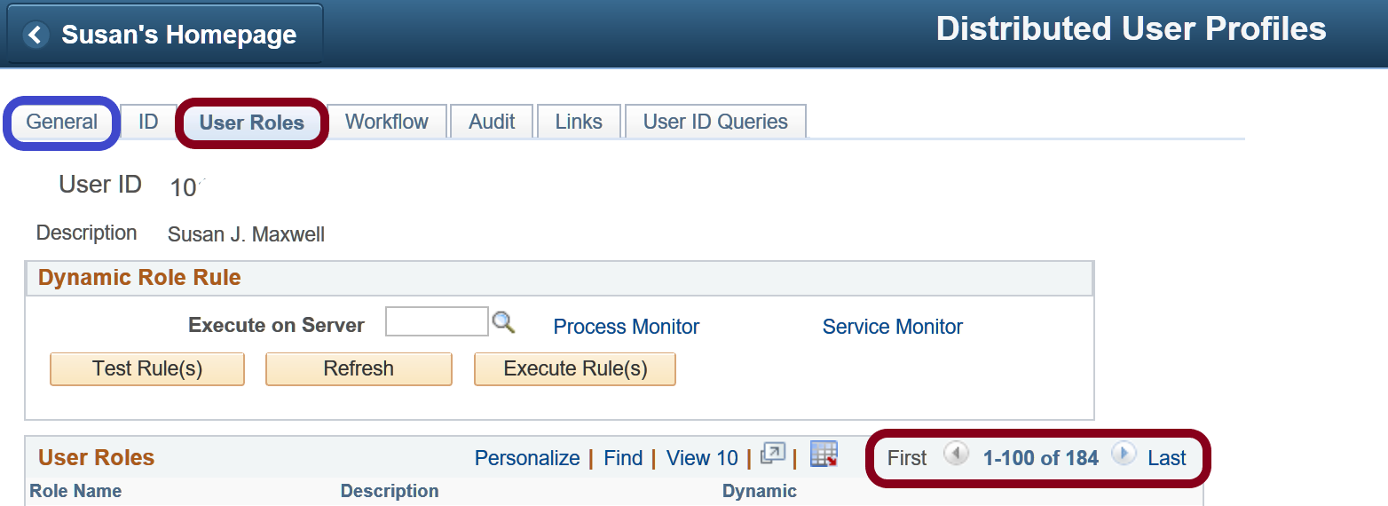

Change the order of fields displayed
You can change the order of fields in a data grid. For example, this class permission data has a number of fields. Not all are necessary when granting the permission. The comment field at the end if very important.
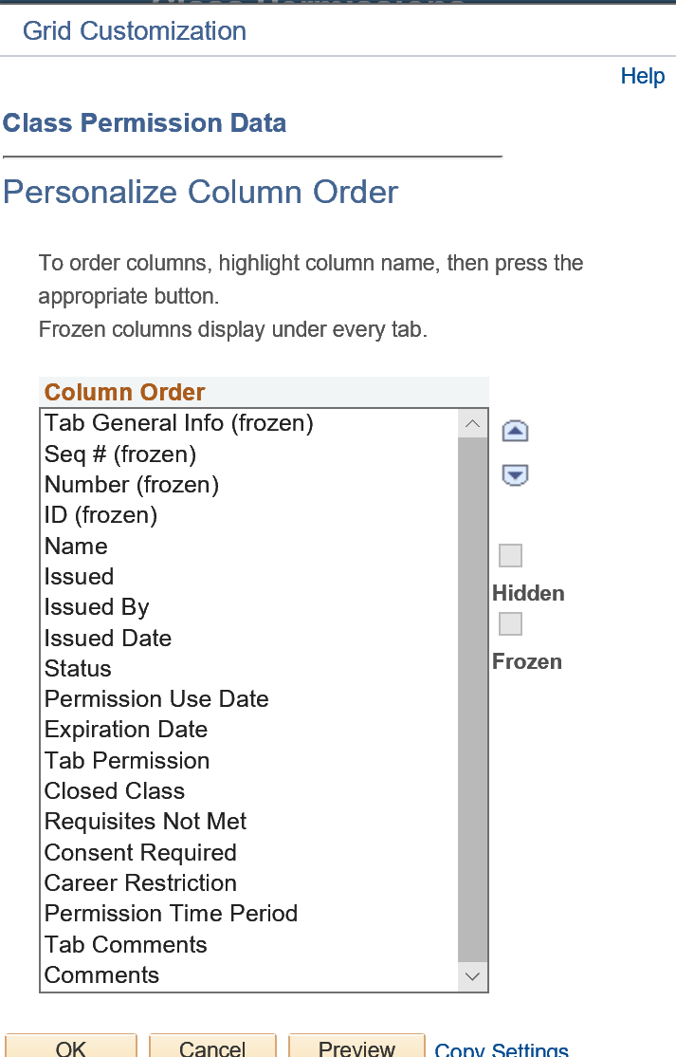
When you see the multiple tabs and the “show all columns” button you can click on the Personalize link.

You will see the list of fields. You can reorder fields. Put those fields that you need to enter data into at the top, in the order you want to enter the data, or view the data.

Example of reordered columns.
Unfortunately, there is no way to change what displays on each tab or the name of the tab. The first tab will display as much as it can fit, then move on the second tab, etc.

Save a Search
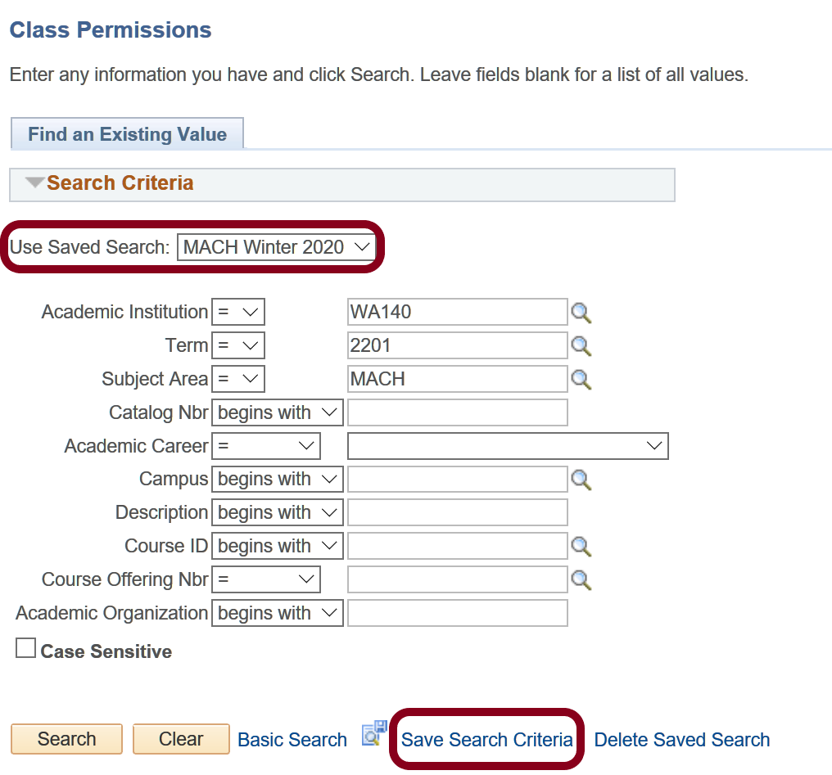
If you use the same search parameters each time you search in a particular page you can save that search criteria, name it, and then use the saved search when needed instead of filling in all the information each time.

Multiple person records

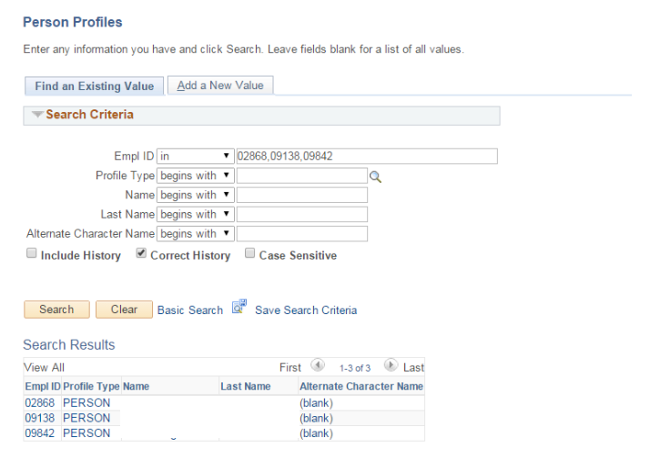
If you are working with a long list of people on a PeopleSoft component, rather than searching every time, you can use the “IN” condition to fetch all the records at one time. Then you can go down the list or use the next record.

Search Match
Always SEARCH before you create a new person record. Always use Search Match. Duplicate students must be sent to SBCTC and is a manual, time consuming process.
Navigation: Main Menu → Campus Community → Personal Information(student)→ Search/Match
Navigation: Main Menu > Workforce Administration > Personal Information > Search Match Internal/External
In the Search Type field, select Person
In the Search Parameter field, select PSCS_TRADTIONAL
Then Save Search Criteria, and name your search.
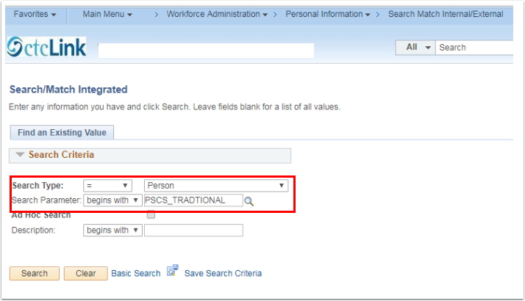
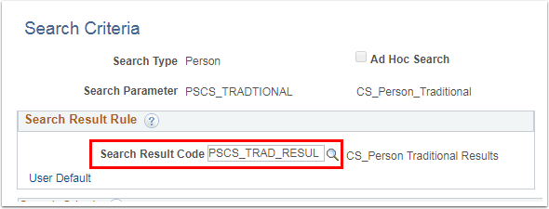
In the Search Result Code field click on User Default, then use the lookup icon and select PSCS_TRAD_RESUL. Click on “Return to advanced search” and this will save this information as the default.
Now save to favorites – in whichever ways you want (homepage, navbar, favorites).

You can search on as few as 3 characters

Multiple Windows
You can open a second instance of PeopleSoft in a different browser, or you can open a second window.
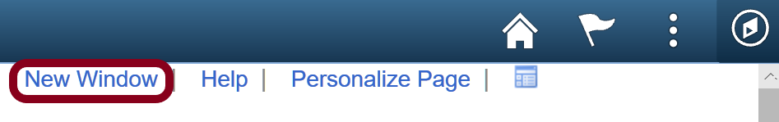

Alphabetizing
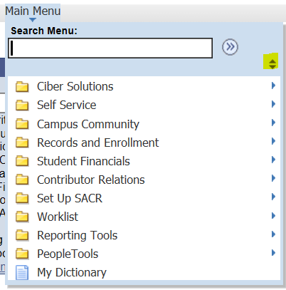
To alphabetize a list use the up/down arrows. This will ONLY work if you are using classic pages.

Non PeopleSoft Tips

Outlook
Create a contact group for a group of people you regularly have to email.
Change a display name in My Contacts (double click, change display as). Useful when you have two people with the same name like Christy Campbell.

