Post Sabbatical Report for Garrett C. Gregor
- Summary
  - Preparation and Planning
The preparation for this project started in 2008 when I took a course in chemistry (Chem&141) from Susan Brookhart, who taught the class by a method known as Process-Oriented Guided-Inquiry Learning (POGIL). Students work in groups through a booklet of activities, with each student assigned a role designed to help the group function cohesively. A POGIL activity is constructed based on asking students questions that follow a learning cycle (which are exploration, concept invention, and application) and begins with a model that is usually a picture, drawing, graph, or table that students investigate through the questions. The instructor acts as facilitator, as students learn concepts through the activities, and the mode is primarily active learning, with lecture only as needed.
I was attracted to active learning and attended POGIL workshops to learn more about it. In 2012, I was invited to participate in a beta test study for a new POGIL workbook for Calculus I, the first math book published under this style. Later, Susan and I gave a presentation to the Clark College Board of Trustees on POGIL and how the roles (manager, presenter, quality controller, and reflector) represented the soft skills desired by employers in those they hire.
Oddly, no more POGIL math texts were published, although one has been said to have been in the works for precalculus for several years. I attended two more workshops on advanced POGIL training and focused on activity writing. Since that time, I have sporadically written several activities for multiple levels of math courses from basic algebra through differential equations. However, creating each activity is time consuming on a scale far greater than creating a standard lesson.
  - Project Products and/or Accomplishments
I created eight guided-inquiry activities that tie concepts taught in science courses to the mathematics that is used within each topic. The activities are written for a pre-calculus, college algebra course with models used from physics, chemistry, and biology.
  - Research
I reached out to science faculty at Clark College, who gave me topics to read and labs to work through. Most topics came from sections of the textbooks used in the major’s sequence for physics, biology and chemistry. I also researched online for further topics, as well as models and pictures to incorporate in the activities.
  - Self-enrichment
Originally, my wife and I had some plans to go birding (we are avid birdwatchers) in May in Magee Marsh Wildlife Area in Ohio during peak migration. However, COVID-19 derailed all plans for travel, including being able to see any of my family. I spent a lot of time reading news and journal articles, learning to brew kombucha, and brewing many gallons of beer and supplying the spoils to my neighbors, particularly the ones with children as schools closed and their lives became vastly more challenging. I also hiked in Forest Park in Portland about five to six times a week, which paid dividends toward my physical and mental health.

- Chronicle of Sabbatical Activities
The starting point for this project hinged on active collaboration with science faculty. Because of the pandemic, Spring term was delayed by two weeks, and most science faculty were scrambling to figure out how to teach online. As a consequence, all faculty contacted were not ready to help with the project and my ability to collaborate with them was delayed by a few weeks, if at all.
Week 1: I started working on the first activity. Read about the rate law in chemistry and worked through a lab on the ionization of acetone. Developed the first activity as a motivation to solve exponential equations based using the rate law as a basis.
Week 2: Completed the first activity. Read about reaction orders and the Arrhenius equation, which is a linearization of an exponential equation. Researched visual models online to act as the model for an activity. Started working on a second activity on logarithm rules.
Week 3: Set the second activity aside: found it difficult to develop exploration questions on logarithmic rules using the Arrhenius equation as a basis. Found the equation to be a better fit at the end of an activity than the beginning. Started researching and reading about physics topics including Coulomb’s law and the Newtonian laws of gravity.
Week 4: Started a third activity on rational functions. Researched Michaelis-Menten kinetics and body mass index (in biology), but decided Coulomb’s law would be the most approachable model for this topic.
Week 5: Most of the time spent completing the third activity. Reached out again to science faculty for more ideas. Heard back from some, but not others.
Week 6: Explored the experimental tool Logger Pro, which is used by physics faculty in labs to record and model data in real time. Studied and worked through a lab on the gravity constant for throwing a ball up in the air, which led to developing the fourth activity on quadratic functions.
Week 7: Spent most of this week reading a researching from texts and online, including Von Bertalanffy growth curve (models the mean length of an animal as a function of age), his equation for tumor growth, Kepler’s Laws for elliptical motion, and worked through a meteorology humidity lab. Started sketching out the fifth, six and seventh activities.
Week 8: Completed the fifth activity on power functions. Worked more on the sixth activity.
Week 9: Completed the sixth activity on elliptical motion. Revisited the second activity and worked on approaching it from another direction. Worked through an oceanography lab on tidal motion, but it was more applicable to a trigonometry course than college algebra.
Week 10: Revisited the humidity lab as a basis for two activities on the basics of functions and linear functions. Completed the seventh and eighth activities.

- Sabbatical Objectives (restate objectives and elaborate on whether each objective was met)
The objective was to create eight active-learning interdisciplinary course activities for college algebra. Each activity was to include a motivating problem, key concept, or application that is taught or developed in a STEM course at Clark College. I was to collaborate with science faculty and research topics in chemistry, physics, biology, engineering, computer science, geology, and environmental science that align with topics in college algebra. Each activity was to develop a particular topic in mathematics within a scientific context.” This objective was met, although activities were not created for every field.

- Benefit of Sabbatical to Students
Students will gain a better understanding of the connections between mathematics and their science courses. The mathematics that students learn to apply in science courses will be repeated and supported in the college algebra class. Students will also benefit from pedagogy that supports an active learning environment.

- Value of Project to the College and the Mathematics Division
Mathematics faculty who use the activities will gain more insight into the related topics taught by science faculty, including the notation that is used in science courses. Mathematics faculty will better understand the specific mathematical tools and concepts that are emphasized in science courses, which may be used to inform and adjust college algebra curricula to align with science.

- How the Project Enhanced Previous Professional Work
I have been interested in writing and developing guided inquiry activities since I started my involvement with POGIL. Writing an activity takes a considerable amount of time and effort that I rarely am able to accomplish while teaching a full load during a term. These activities will expand the bank of other activities that I have created for college algebra, and allow me to incorporate guided inquiry into a college algebra class on an almost weekly basis. The project also allowed me to practice writing, and learn better, and more efficient ways to approach activity writing.

- Institutions or Organizations affiliated with the Project
No institutions or organizations were affiliated with this project.

- Grants or Stipends Used for the Project
No grants or stipends were used for this project.

- Copy of Original Application
Professional Placement & Advancement Committee |  |  |  | Application for Sabbatical Leave
Applying for Sabbatical Leave:

Review “Article V – Leaves, Section N - Sabbatical Leave” of the AHE Contract for details and policies related to Sabbatical Leave
Discuss your Sabbatical Leave with your Dean and Dept. Head/Division Chair. Letters of support are encouraged but not required.
Complete this form in Microsoft Word
Print and sign application, obtain Dean’s signature, attach any supporting documentation, and mail to PPAC at Mail Stop BHL 127
1. Name |  | 2. Department | 3. Division |  | 4. Unit
Garrett Gregor |  | Mathematics | Mathematics

5. Please summarize your project proposal in 1-3 sentences. | I propose to develop eight active-learning interdisciplinary course activities for college algebra (Math 110/111) to be implemented in Clark College mathematics courses, each will include topics and concepts used in science courses.

6. Quarter(s) and Year Requested | Quarter Year | Quarter Year | Quarter Year | Quarter Year
 | 2020

7. Have you been awarded sabbatical previously? If yes, please list quarters: Fall 2009, Winter 2010, Spring 2010

8. What date did you begin teaching full-time at Clark College? | 9/1/2002

By checking this box I confirm that I accept the following policies:
- I understand that, should I fail to meet the provisions of returning to the College as specified in the Sabbatical Leave Policy, I will reimburse the College for the amount of remuneration received by me during this period.

- I understand that I am obliged to carry out the activity/activities outlined in the attached Sabbatical Leave Proposal or to gain approval for an alternative.

- I understand that I am required to submit a Post-Sabbatical Report no later than the end of the first quarter after returning to the College. Contact the PPAC secretary for details on the expectations of the Post-Sabbatical Report.

- I understand that no additions, revisions, or editing of my application will be accepted after the final application deadline.

••••••••••••••••••••
Signature of Applicant | Unit Dean Signature Acknowledging Application
Committee Use Only:
PPAC Chairperson Verifies Committee Recommendation |  |  | Vice President of Instruction Recommends Approval
President Recommends Approval |  |  | Date Approved by Board of Trustees
Application Received | PPAC Reviewed | Committee Decision and Comments
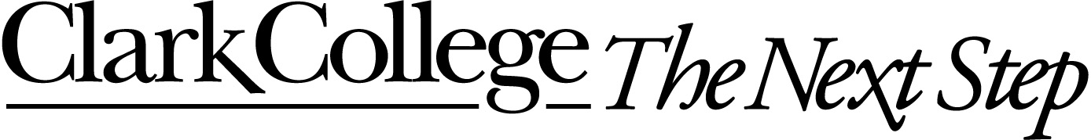

9. Provide a detailed description of your proposal, objectives, and plan (travel, formal study, research, where, etc.).

Several first-year major-level courses in the sciences require college algebra as either a pre-requisite or co-requisite course. Most science applications in math textbooks are canned or have been massaged to fit the mathematics topic to the level that students do not see the connection to the science. Most topics in mathematics textbooks are developed theoretically outside of context, which train new mathematics instructors to believe that it is the purview of science faculty to make the connections between math and science for students.

I would like to create eight active-learning interdisciplinary course activities for college algebra. Each activity will include a motivating problem, key concept, or application that is taught or developed in a STEM course at Clark College. I will collaborate with science faculty and research topics in chemistry, physics, biology, engineering, computer science, geology, and environmental science that align with topics in college algebra. Each activity will develop a particular topic in mathematics within a scientific context. Students will gain a better understanding of the connections between mathematics and their science courses. Mathematics faculty who use the activities will gain more insight into the related topics taught by science faculty.

10. Provide a detailed time sequence for completion of the project.

April 2020: I will meet with key faculty in the chemistry, physics, biology, geology, engineering, computer science, and environmental science departments. I will research applications in these areas and match them with key topics in college algebra.

May 2020: I will write and develop each activity so that it has, at its center, a single topic from one of the fields mentioned that connects with a topic in mathematics. I will present activities to science faculty for review.

June 2020: Continue writing and revising activities. Depending on the timing during the quarter, I may ask a faculty member in a current college algebra course to use an activity as a trial run in their course. I would use that feedback to revise and improve the activities.

11. Describe how your project will add value to the College and your Instructional Division or Department.

“Implementing active learning strategies” is a goal of the 2016-2021 Academic Plan (Goal 5). As the Clark College faculty work towards this goal, I would like to be a leader within my department to help faculty learn and implement successful techniques of active learning. The activities I create will develop a framework for faculty who are seeking more experience in active learning.

The collaboration with science faculty may reveal concepts and skills that should be emphasized or de-emphasized in the college algebra curriculum. This collaboration will be valuable to foster connections and communication, especially since the departments are so far from each other geographically.

12. Describe how your Sabbatical activities will benefit the students at Clark College.

Students will see the connections between their math and science classes more clearly. For students who are simultaneously taking a science course with college algebra, they will receive more continuity of subject matter within the STEM pathway. Clearer connections between math and science topics will support student learning and success.

13. Has any work been done specifically in preparation for the sabbatical leave project?

I have attended three regional POGIL workshops since 2010 in intermediate and advanced tracks of study to learn how to be a practitioner of active learning group facilitation and guided inquiry writing. In 2011-2012 school year, I was one of the beta testers for the activity workbook “Calculus I: A Guided Inquiry” by Straumanis et. al. I implemented the activities in the workbook, gave detailed feedback to the authors, and was part of a research study on the effectiveness of guided inquiry in calculus conducted by faculty and graduate students at Portland State University.

14. List any institutions or other organizations which will be affiliated with the project.

No other institutions or organizations will be involved.

15. List all anticipated expenses and modes of payment (e.g. grants, stipends, college funding, IFDF, personal funding, etc.)

No expenses are anticipated.

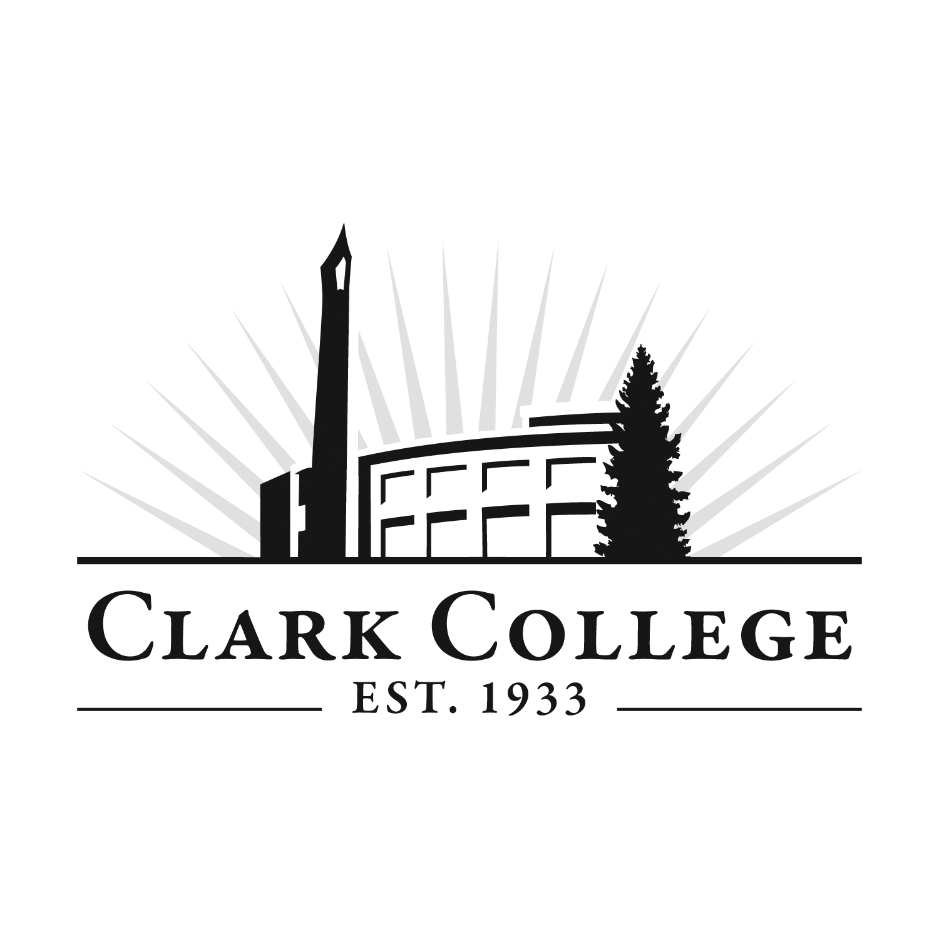

Form revised by Tyler Chen on 10.15.09

